
General Letter : 2100 Istanbul, 23/12/2025
EQUITIES CLEARING AND SETTLEMENT TEAM
Subject : In Cash Creation and Redemption of Exchange Traded Funds (ETF) Shares
Related Parties : Banks, Brokerage Houses, Portfolio Management Companies
Dear General Manager,
As is known, under the current Creation and Redemption process, it is required that the underlying asset in Portfolio Composition File (PCF) be held in the securities account of the Authorized Participant or in the account of the client executing the relevant transaction.
Pursuant to the Article 2 of Capital Markets Board(SPK) Communiqué On Principles Of Exchange Traded Funds (III-52.2), “In cash based primary market transactions, the principles relating to liabilities and responsibilities of the founder, portfolio custodian, authorized participant and portfolio manager are determined with a prior consent of the Board, and these principles are included in the fund rules and prospectus.” it is possible that Creation/Redemption transactions are conducted in-cash as well.
With the enhancement pursuant to the regulation, Creation and Redemption transactions can be executed by using in-cash of the underlying assets in PCF without any requirement to deposit underlying securities into the Authorized Participant or the client securities account.
During in-cash transactions:
- Execution of In-cash transaction is based on the amount listed in the column of “Unit Transaction Amount”(İşlem Birim Tutar) in PCF. Therefore, it is crucial that relevant column is calculated properly.
- Cash Transaction Option is supposed to be selected as Yes (Y) or No (N), while entering a Creation/Redemption instruction by using “Exchange Traded Funds Transactions” Submenu on Takasbank Member Web Menu.
The relevant development will be implemented as of 24/12/2025.
Kindly submitted for your information.
Sincerely Yours,

TAKASBANK
ISTANBUL SETTLEMENT AND CUSTODY BANK INC.

Muhterem ÇELİK Gökhan ELİBOL
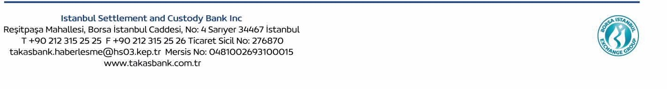
Director Executive Vice President

